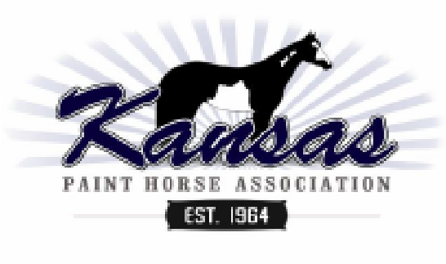
2024 Kansas Paint Horse Association Membership Application
(Expires December 31, 2024)
Type of Membership (Circle one):
Individual $30 Husband/Wife $40 Ranch $40 Youth $10 each
Youth memberships are given only with a corresponding adult membership. A ranch membership can be held in the name of only two individuals, related or not, and entitles that membership to two votes on Association matters of General Membership business.
Adult Member:
Adult Member:
Ranch Name:
Address:  Email Address:  Website:  Primary Phone#  Youth Member(s): | City: | State: | Zip:
Name: |  | Birthdate:
If you prefer NOT to have your membership Information included in KPHA publications such as the membership directory and the website, please check this box.
Dues may be paid via check, cash or Paypal (Kansas Paint Horse Association)
Make checks payable to KPHA and mail to:
Sheri Grinstead
3010 E 56th St
Hutchinson, KS 67502 For office use:
Date Received:
Amount:
Check number: Cash Paypal

