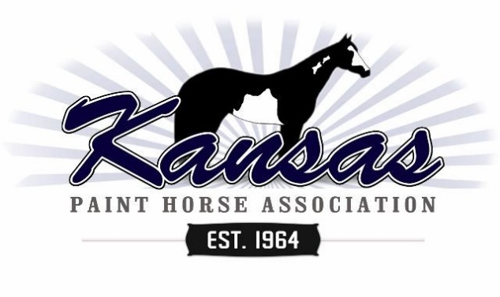
Kansas Paint Horse Year End Award Nomination Form
$5 KPHA Nomination Year End High Point fee per Horse/Rider Per Division
Exhibitor Name
Horse Name
APHA Registration #

 | Youth Walk / Trot Division |  | Amateur Walk Trot Division
 | Novice Youth Division |  | Novice Amateur Division
 | Youth 18 and Under Division |  | Amateur Division
 | Youth 13 and Under Division |  | Amateur Solid Paint Bred Division
 | Youth All Breed Division |  | Adult All Breed Division
 | Yearling Longe Line/Halter/In Hand Trail |  | 2 Year Old Longe Line/Halter/In Hand Trail
 | Youth Ranch Division |  | Novice Amateur Ranch Division
 |  |  | Amateur Ranch Division
 | Youth All Ranch Breed Division |  | Adult All Breed Ranch Division
 | Youth Walk/Trot All Breed |  | Adult Walk/Trot All Breed
 |  |  | Amateur Solid Paint Bred Ranch

# Division @$5 |  | Total | $ .00

Qualifying points from 1 Youth Halter Class apply to Youth High Point per show.
Qualifying points from 1 Open or Amateur Halter Class apply to Amateur High Point per show.
FREE EWD/Lead-Line/Walk-Whoa divisions without horse/rider commitment.

